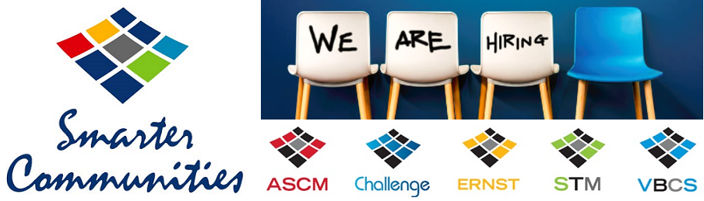

National Proposal and Bid Manager – Smarter Communities
Sydney CBD

Your new company
Smarter Communities is one of the largest and leading community management companies in Australia. Operating in New South Wales, Queensland, South Australia and Victoria, we specialise in strata, body corporate and community titles management. We manage more than AU$30 billion of property and our vision is clear — to deliver smarter solutions that create a better lifestyle for people living and invested in communities.

Due to ongoing growth, we are seeking a National Proposal and Bid Manager to join our business. This is a unique and exciting position that will give the successful candidate the opportunity to directly contribute to growing our business.

Your new role
- A pivotal member of the Growth team, reporting into a highly respected and passionate Head of Growth
- Develop the proposal process, including baseline content and digital templates to streamline the process and improve win rates
- Work alongside Senior Business Development Manager on top-tier pursuits and write compelling, high-impact content
- Research, manage, lead and quality control the proposal process
- Act as the central point of contact for all proposals and provide reports and analysis, as required
- Be a key contributor to drive a customer-centric approach to pitching/proposals
- Work alongside our Graphic Designer to create high-impact presentations
- Research markets, trends and competitors to help identify growth opportunities

What you'll need to succeed
- Mastery of the English language — ability to write sharp, persuasive content that resonates with non-technical clients
- Ability to get written messages across without the clutter
- Impeccable organisational and prioritisation skills
- Ability to work within a fast-paced team environment
- Demonstrated track record in increasing win rates
- Experience creating proposal templates (using digital mediums is a plus)
- Highly driven and self-motivated to hit targets
- Methodical research and fact-finding, followed by high-level summaries of key points
- Ability to influence, engage and build trust with others, including clients and team members
- Degree qualified in Management, Real Estate, Business or other related discipline is essential
- Understanding of body corporate or strata is advantageous, but not essential

What you’ll love about us
We provide a diverse and inclusive work environment and offer many personal and professional development opportunities. We also highly value work-life balance. Some of our many benefits include:
- Flexible working hours and working from home
- Salary continuance insurance
- Social events and celebrations
- Education and study assistance
- Opportunity to purchase leave
- Discounts with major stores

What you need to do now
If this role sounds like the right fit for you, please send your up-to-date resume through to Nina Prodywus (People & Culture Business Partner) nprodywus@smartercommunities.com.au, for a confidential conversation.

